The Rube Goldberg Machine assignment, due Friday, November 18th*

(assigned to friends four years and older, but younger friends can also bring in pictures and show their work!)
*This is a soft due date…the children can send over their videos any time before December!
Hello, dear Parents and Children!
It’s time for a new project! Your children have finished studying simple machines and have enjoyed learning about ramps/inclined planes, wedges, levers, pulleys, wheels and axels, and screws.
Here’s a picture of each simple machine just in case they need a reminder for this project!
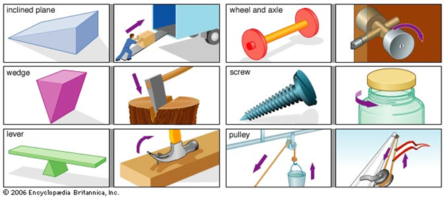
We will use our knowledge of simple machines to design a Rube Goldberg machine. Rube Goldberg machines are fantastical, complicated inventions that help meet simple needs or wants.
For inspiration, watch this gentleman serve himself (and his child) a piece of cake: https://www.youtube.com/watch?v=auIlGqEyTm8
Here’s a young student who designed his own Rube Goldberg machine: https://www.youtube.com/watch?v=OHwDf8njVfo
Friends, can you find examples of simple machines used in these videos?
You will think of a simple need/want you would like help with and draw a picture of your Rube Goldberg machine meeting the demands of that problem. Photographs and videos are also much appreciated and can be shown to the classrooms with our teacher tablets!
1. Think about what simple need or want you would like help with. This need could be something like turning on a switch, tipping over salt on your food, pushing a button, etc.
2. Think about what materials you will need to create this machine. In the second video with the student, he used things that you probably have around your house! Is there anything that you might throw away or recycle this week, such as water bottles or paper towel rolls, that you could use for your machine?
3. Design your machine by sketching your ideas out on paper first. Rube Goldberg, the creator of these fantastic machines, was an amazing cartoonist! Here’s his example of a self-operating napkin:
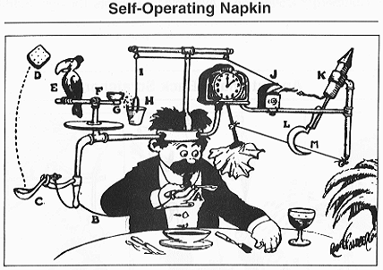
4. If you are building a portion or all of your machine, please record your Rube Goldberg machine in action and email it to us!
Drawings, videos, and/or pictures are due on Friday, November 18th. If you need help or have any questions, please feel free to email me 😊 I hope you all have a wonderful time!

