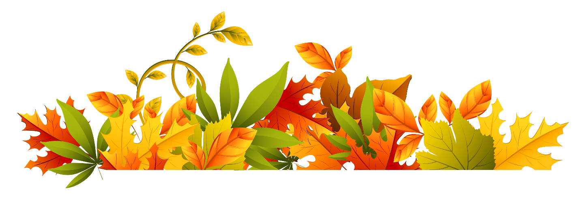

Friday, October 28th is the
Natural Pumpkin Fashion Show!

Please help your child decorate a pumpkin using only materials found in nature. You can use branches, leaves from the ground, stones/pebbles, seeds, wood chips, petals, and all the other wonderful things that nature provides.
Adhesives do not need to be natural and can include hot glue, gorilla glue, or nails.
Due to space limitations, please decorate jack-be-little or pie pumpkins.
The Natural Pumpkin Fashion Show is one of my favorite mornings. As you walk into school on October 28th, please take that moment with your child to study and to marvel at all the creative and unique pumpkins parading into school with our friends. I’ll post pictures on the blog of our creations. The pumpkins will head back home with your child that afternoon!

