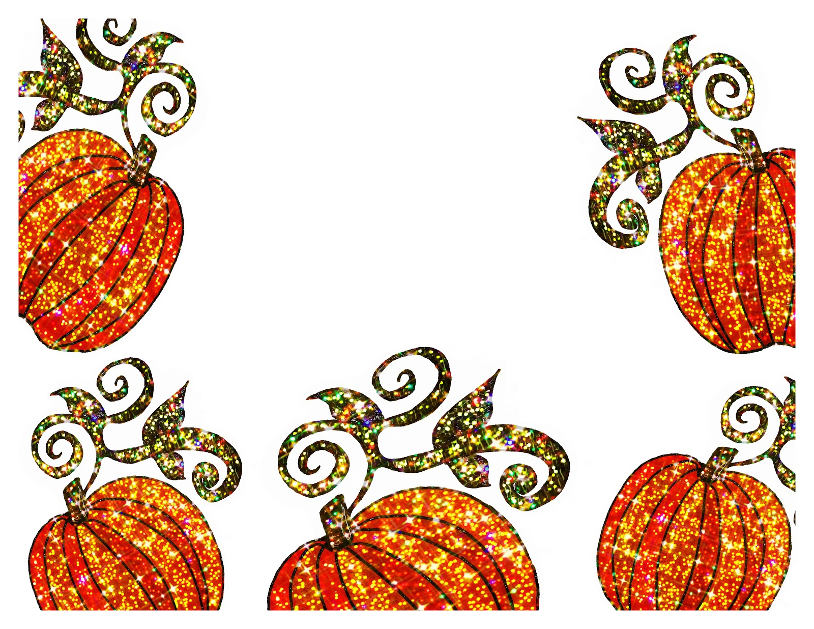
The Great Pumpkin Challenge!
This Photo by Unknown Author is licensed under CC BY-NC-ND
Pumpkin due on Wednesday, October 16th

Objective: To design a marvelous and unique pumpkin using only objects found in nature!

Who can participate? Everyone! Parents, of course you are very welcome to help your child with some of the adhesive necessities in this activity (hammer & nails, hot glue).

What materials are needed? Please use a mini pumpkin. Use only natural objects to decorate your pumpkin. These objects could include hay, acorns, leaves that have fallen from a tree or bush (not leaves that you must pick from a tree!), dried corn, pecans, or old stems or seeds from other fruits and vegetables. Please, no googly eyes, pom-poms, etc. We want to work our creative muscles!
Attach your natural materials in whatever way will make them adhere to the pumpkin!

On Wednesday, October 16th, the children will bring their pumpkins
to school to show all their friends. The pumpkins will head
home that same day to decorate your home space for fall!

