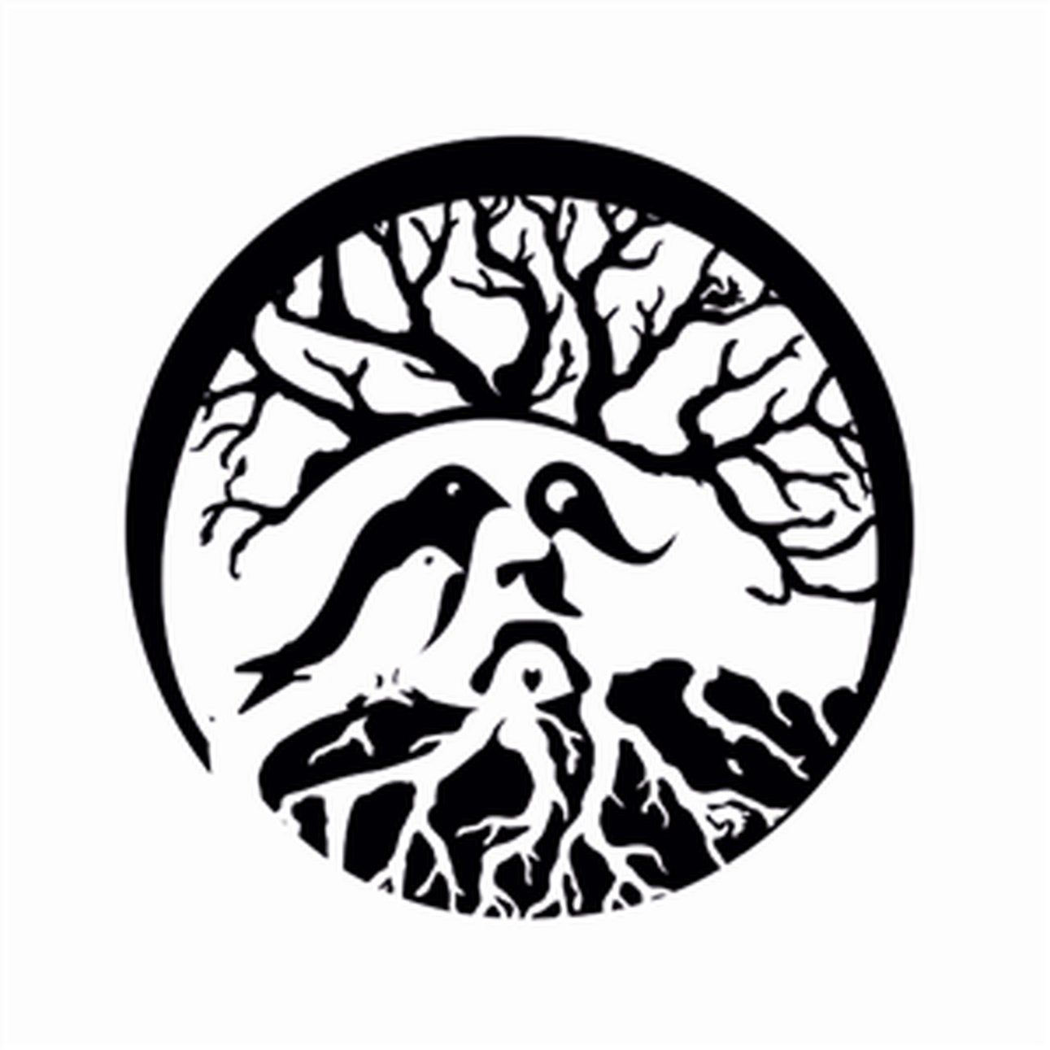

Fall Poetry Recitals dates:
Ms. Jerical’s class: Saturday, 10/5, @ 9 a.m.
Ms. Gabi’s class: Saturday, 10/5, @ 10 a.m.
Ms. Joanna’s class: Saturday, 10/12, @ 9 a.m.
Ms. TaQueria’s class: Saturday, 10/12,
@ 10 a.m.

