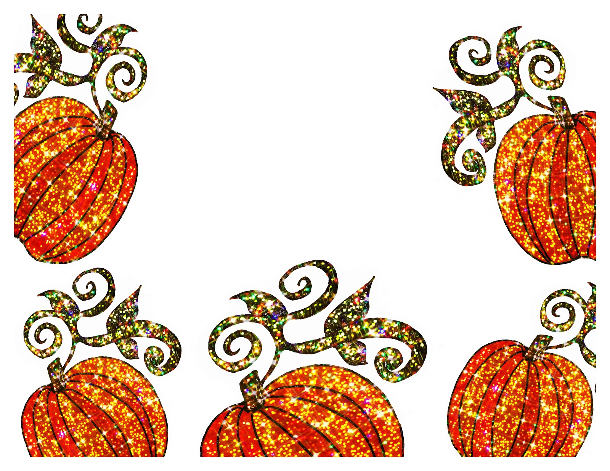
The Great Pumpkin Challenge!
This Photo by Unknown Author is licensed under CC BY-NC-ND
Pumpkin due on Wednesday, October 24th

Objective: To design a marvelous and unique pumpkin using only objects found in nature!

Who can participate? Everyone! Parents, your child will probably need some help if they need to hammer an acorn in for an eye or hot glue straw hair to their pumpkins.

What materials are needed? Please use a mini pumpkin to help us create room for everyone to share their creation. Please use only natural objects to decorate your pumpkin. These might include hay, acorns, leaves that have fallen from a tree or bush (not leaves that you must pick from a tree!), dried corn, pecans, or old stems or seeds from other fruits and vegetables. Please no googly eyes, pom-poms, etc. We want to work our creative muscles!
Attach your natural materials in whatever way will make them adhere to the pumpkin!

On Wednesday, October 24th, the children will bring their pumpkins
to school to show all their friends. The pumpkins will head
home that same day to decorate your home space for fall!

